TITLE

Frank van Smeden ~ s1101560
Wouter Eekhout 1099353

abstract

introduction

Statistical report

Statistics
 |  | age | fnlwgt | educationnum | Capitalgain | capitalloss | Hoursperweek
N | Valid | 32561 | 32561 | 32561 | 32561 | 32561 | 32561
N | Missing | 0 | 0 | 0 | 0 | 0 | 0
Mean |  | 38,58 | 189778,37 | 10,08 | 1077,65 | 87,30 | 40,44
Median |  | 37,00 | 178356,00 | 10,00 | ,00 | ,00 | 40,00
Std. Deviation |  | 13,640 | 105549,978 | 2,573 | 7385,292 | 402,960 | 12,347
Minimum |  | 17 | 12285 | 1 | 0 | 0 | 1
Maximum |  | 90 | 1484705 | 16 | 99999 | 4356 | 99

Descriptives
 |  |  | Statistic | Std. Error
age | Mean |  | 38,58 | ,076
age | 95% Confidence Interval for Mean | Lower Bound | 38,43
age | 95% Confidence Interval for Mean | Upper Bound | 38,73
age | 5% Trimmed Mean |  | 37,99
age | Median |  | 37,00
age | Variance |  | 186,061
age | Std. Deviation |  | 13,640
age | Minimum |  | 17
age | Maximum |  | 90
age | Range |  | 73
age | Interquartile Range |  | 20
age | Skewness |  | ,559 | ,014
age | Kurtosis |  | -,166 | ,027
fnlwgt | Mean |  | 189778,37 | 584,937
fnlwgt | 95% Confidence Interval for Mean | Lower Bound | 188631,87
fnlwgt | 95% Confidence Interval for Mean | Upper Bound | 190924,86
fnlwgt | 5% Trimmed Mean |  | 183146,49
fnlwgt | Median |  | 189778,37
fnlwgt | Variance |  | 1,114E10
fnlwgt | Std. Deviation |  | 105549,978
fnlwgt | Minimum |  | 12285
fnlwgt | Maximum |  | 1484705
fnlwgt | Range |  | 1472420
fnlwgt | Interquartile Range |  | 119237
fnlwgt | Skewness |  | 1,447 | ,014
fnlwgt | Kurtosis |  | 6,219 | ,027
educationnum | Mean |  | 10,08 | ,014
educationnum | 95% Confidence Interval for Mean | Lower Bound | 10,05
educationnum | 95% Confidence Interval for Mean | Upper Bound | 10,11
educationnum | 5% Trimmed Mean |  | 10,17
educationnum | Median |  | 10,00
educationnum | Variance |  | 6,619
educationnum | Std. Deviation |  | 2,573
educationnum | Minimum |  | 1
educationnum | Maximum |  | 16
educationnum | Range |  | 15
educationnum | Interquartile Range |  | 3
educationnum | Skewness |  | -,312 | ,014
educationnum | Kurtosis |  | ,623 | ,027
Capitalgain | Mean |  | 1077,65 | 40,928
Capitalgain | 95% Confidence Interval for Mean | Lower Bound | 997,43
Capitalgain | 95% Confidence Interval for Mean | Upper Bound | 1157,87
Capitalgain | 5% Trimmed Mean |  | 113,80
Capitalgain | Median |  | ,00
Capitalgain | Variance |  | 5,454E7
Capitalgain | Std. Deviation |  | 7385,292
Capitalgain | Minimum |  | 0
Capitalgain | Maximum |  | 99999
Capitalgain | Range |  | 99999
Capitalgain | Interquartile Range |  | 0
Capitalgain | Skewness |  | 11,954 | ,014
Capitalgain | Kurtosis |  | 154,799 | ,027
capitalloss | Mean |  | 87,30 | 2,233
capitalloss | 95% Confidence Interval for Mean | Lower Bound | 82,93
capitalloss | 95% Confidence Interval for Mean | Upper Bound | 91,68
capitalloss | 5% Trimmed Mean |  | ,00
capitalloss | Median |  | ,00
capitalloss | Variance |  | 162376,938
capitalloss | Std. Deviation |  | 402,960
capitalloss | Minimum |  | 0
capitalloss | Maximum |  | 4356
capitalloss | Range |  | 4356
capitalloss | Interquartile Range |  | 0
capitalloss | Skewness |  | 4,595 | ,014
capitalloss | Kurtosis |  | 20,377 | ,027
Hoursperweek | Mean |  | 40,44 | ,068
Hoursperweek | 95% Confidence Interval for Mean | Lower Bound | 40,30
Hoursperweek | 95% Confidence Interval for Mean | Upper Bound | 40,57
Hoursperweek | 5% Trimmed Mean |  | 40,42
Hoursperweek | Median |  | 40,00
Hoursperweek | Variance |  | 152,459
Hoursperweek | Std. Deviation |  | 12,347
Hoursperweek | Minimum |  | 1
Hoursperweek | Maximum |  | 99
Hoursperweek | Range |  | 98
Hoursperweek | Interquartile Range |  | 5
Hoursperweek | Skewness |  | ,228 | ,014
Hoursperweek | Kurtosis |  | 2,917 | ,027

Age
Minimum | 17
Maximum | 90
Mean | 38.582
Standard deviation | 13.64

Fnlwgt
Minimum | 12285
Maximum | 1484705
Mean | 189778.367
Standard deviation | 105549.978

Education-num
Minimum | 1
Maximum | 16
Mean | 10.081
Standard deviation | 2.573

Capital-gain
Minimum | 0
Maximum | 99999
Mean | 1077.649
Standard deviation | 7385.292

Capital-loss
Minimum | 0
Maximum | 4356
Mean | 87.304
Standard deviation | 402.96

Hours-per-week
Minimum | 1
Maximum | 99
Mean | 40.437
Standard deviation | 12.347

Code description

Experiments:
- Instances: What data did you use for the experiments?
- Any pre-processing done to improve the quality of your results.
- Your system parameters.
- Any post-processing done to improve the quality of your results.
- Analysis of results of the experiment and their significance.

Apriori
Instances: What data did you use for the experiments?
Used the following:
- workclass
- aducation
- marital-status
- occupation
- relationship
- race
- sex
- native-country
- yearly income

The others didn’t work because these are numerical values. Only nominal values are supported for Apriori
Any pre-processing done to improve the quality of your results.
None (Frank we need to look at this)

Your system parameters
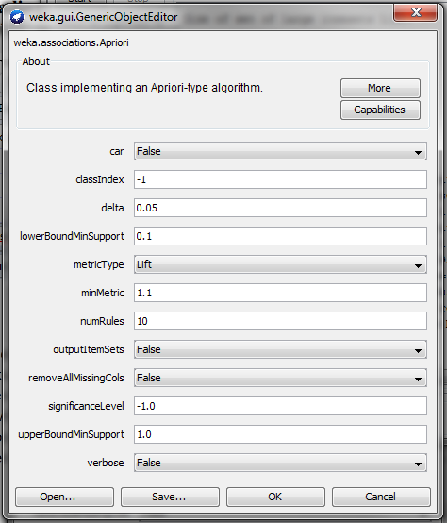
Any post-processing done to improve the quality of your results
As you can see in the configuration; lift (Frank: Ik heb het nog niet kunnen filteren met de Kulzcynski and de imbalance ratio (IR)) is used to improve the quality of the results

Analysis of results of the experiment and their significance.
=== Run information ===

Scheme: weka.associations.Apriori -N 10 -T 1 -C 1.1 -D 0.05 -U 1.0 -M 0.1 -S -1.0 -c -1
Relation: adult v2-weka.filters.unsupervised.attribute.Remove-R1-weka.filters.unsupervised.attribute.Remove-R2,4,10-12
Instances: 32561
Attributes: 9
workclass
education
marital-status
occupation
relationship
race
sex
native-country
yearly income
=== Associator model (full training set) ===

Apriori
=======

Minimum support: 0.4 (13024 instances)
Minimum metric <lift>: 1.1
Number of cycles performed: 12

Generated sets of large itemsets:
- Size of set of large itemsets L(1): 7
- Size of set of large itemsets L(2): 15
- Size of set of large itemsets L(3): 10
- Size of set of large itemsets L(4): 1

Best rules found:
- relationship= Husband 13193 ==> marital-status= Married-civ-spouse sex= Male 13183 conf:(1) < lift:(2.44)> lev:(0.24) [7786] conv:(708.77)
- marital-status= Married-civ-spouse sex= Male 13319 ==> relationship= Husband 13183 conf:(0.99) < lift:(2.44)> lev:(0.24) [7786] conv:(57.83)
- marital-status= Married-civ-spouse 14976 ==> relationship= Husband 13184 conf:(0.88) < lift:(2.17)> lev:(0.22) [7116] conv:(4.97)
- relationship= Husband 13193 ==> marital-status= Married-civ-spouse 13184 conf:(1) < lift:(2.17)> lev:(0.22) [7116] conv:(712.51)
- marital-status= Married-civ-spouse 14976 ==> relationship= Husband sex= Male 13183 conf:(0.88) < lift:(2.17)> lev:(0.22) [7115] conv:(4.97)
- relationship= Husband sex= Male 13192 ==> marital-status= Married-civ-spouse 13183 conf:(1) < lift:(2.17)> lev:(0.22) [7115] conv:(712.45)
- relationship= Husband 13193 ==> sex= Male 13192 conf:(1) < lift:(1.49)> lev:(0.13) [4363] conv:(2182.09)
- sex= Male 21790 ==> relationship= Husband 13192 conf:(0.61) < lift:(1.49)> lev:(0.13) [4363] conv:(1.51)
- marital-status= Married-civ-spouse relationship= Husband 13184 ==> sex= Male 13183 conf:(1) < lift:(1.49)> lev:(0.13) [4360] conv:(2180.6)
- sex= Male 21790 ==> marital-status= Married-civ-spouse relationship= Husband 13183 conf:(0.61) < lift:(1.49)> lev:(0.13) [4360] conv:(1.51)

FPGrowth
Instances: What data did you use for the experiments?
Used the following:
- sex
- yearly income

The other didn’t work because those are numerical values or nominal values. Only true/false is supported for FPGrowth

Any pre-processing done to improve the quality of your results.
None (Frank we need to look at this)

Your system parameters
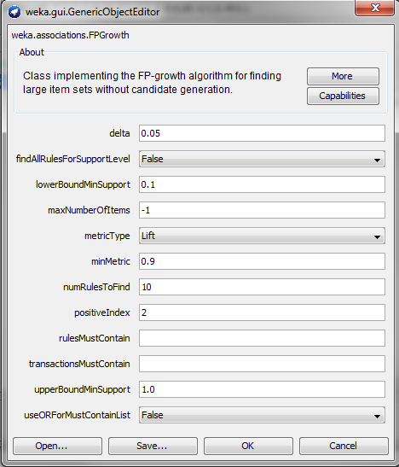
Any post-processing done to improve the quality of your results
As you can see in the configuration; lift (Frank: Ik heb het nog niet kunnen filteren met de Kulzcynski and de imbalance ratio (IR)) is used to improve the quality of the results

Analysis of results of the experiment and their significance.
=== Run information ===

Scheme: weka.associations.FPGrowth -P 2 -I -1 -N 10 -T 1 -C 0.9 -D 0.05 -U 1.0 -M 0.1
Relation: adult v2-weka.filters.unsupervised.attribute.Remove-R1,3,5,11-13-weka.filters.unsupervised.attribute.Remove-R8-weka.filters.unsupervised.attribute.Remove-R1-6
Instances: 32561
Attributes: 2
- sex
- yearly income
=== Associator model (full training set) ===

No rules found!

